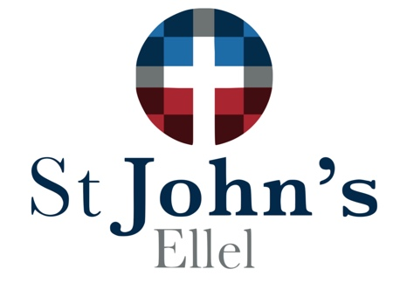

Sunday School Registration Form

Child’s Name:
Date of Birth:
School: |  |  |  | Year Group:
Allergies:
Medical Conditions:
Special Educational Needs:
Is there anything you think we should know about to help support your child?
Parent / Carer’s Name:
Relationship to Child:
Telephone number:
Email address:
Postal address:
Emergency Contact Details:  (Additional to yourself) |  | Name:  Number:

I consent to my child taking part in group activities and declare my child to be in good health and physically able to participate in all activities, other than what I have noted above.
YES / NO

I am aware of the levels of insurance & that I am responsible for arrival and collection of my child at group meeting times. ALSO I will ensure that any change in circumstances will be notified to the organiser.
YES / NO

I am aware that I must stay on site for the duration of the service. YES / NO

I am aware that my child cannot attend Sunday School if they or anyone in my household exhibit any of the following symptoms: a new, continuous cough, a high temperature or a loss / change to sense of taste and/or smell in the 14 days before the session.
YES / NO

I give photo / video consent for:
Internal presentation (eg. Sunday Services) YES / NO
External presentation (eg. Facebook, Church Website) YES / NO

We do our best to ensure that any communication you receive from us is relevant and helpful. At any time you can chose how we contact you. Just opt in (or out) to receive communications at any time by emailing olivia@stjohnsellel.co.uk.
Receive general church emails YES / NO
Receive SMS reminders and alerts regarding Sunday School YES / NO

Name:

Signed:

Date:

